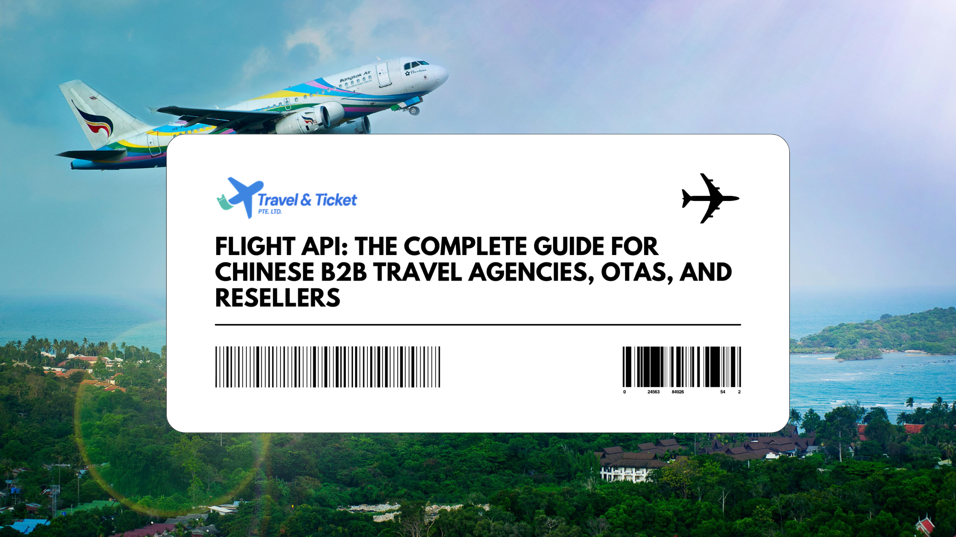

Flight API: The Complete Guide for Chinese B2B Travel Agencies, OTAs, and Resellers
Imagine a traveller in Shanghai searching for the best flight deals to Paris. Within seconds, your platform displays dozens of options—real-time, accurate, and ready to book. Behind that seamless experience lies an invisible powerhouse: the Flight API.
For Chinese B2B travel agencies, OTAs, and resellers, mastering this technology isn’t just a digital upgrade—it’s a strategic leap into global competitiveness. In this guide, we’ll unpack the mechanics, benefits, and best practices of Flight APIs, showing you how they can transform your travel business from a local operation into an international force.

Why Flight APIs Matter for China’s B2B Travel Ecosystem
China’s outbound travel is booming again—and so is competition. B2B travel players must offer fast, flexible, and global booking capabilities. Manual operations can’t keep up.
Flight APIs (机票API/航班API) are becoming the backbone of platforms that want to centralize operations, speed up bookings, and scale their reach—especially through sub-agents. Let’s start with the basics.

What is a Flight API?
Think of a Flight API as a digital travel agent that never sleeps. It connects your system to global sources like airline databases, GDSs (Amadeus, Sabre, Travelport), NDC platforms, and LCCs—fetching prices, availability, schedules, and even issuing tickets on command.
With a Flight API, you can:
- Query schedules, fares, and seat availability
- Create and manage PNRs
- Issue e-tickets
- Retrieve live flight status and historical data
All through standardized endpoints. Common categories include flight booking APIs, flight status APIs, and schedule/timetable APIs.

How a Flight API Works (In Plain Terms)
Here’s how it typically works:
- Search & Pricing: Your portal calls the API to pull real-time routes, fares, and rules from GDS/NDC/LCC sources.
- Offer & Order: When a user selects an option, your system creates a PNR and issues or holds a ticket.
- Post-Booking: Manage cancellations, refunds, reissues, ancillaries, and sync real-time flight status.
- Data Intelligence: Use historical schedules and live feeds to optimize re-protection, disruption alerts, and revenue management.
With the right setup, this entire journey happens in seconds at scale.

Types of Flight APIs (and When to Use Each)
Not all Flight APIs are created equal. Depending on your goals—live bookings, day-of-travel support, or data insights—you’ll use different APIs:
- Flight Booking APIs (GDS/NDC/LCC): For full search-to-ticket flows. Examples: Amadeus, Sabre, Expedia Affiliate.
- Flight Status APIs: Track delays, disruptions, ETAs, terminals, and gate changes. Examples: FlightAware, AeroDataBox.
- Flight Schedule APIs: Timetables and on-time performance data. Examples: OAG, Cirium.
- Fare/Pricing APIs: For low-fare search, branded fares, and ancillaries.
- Airport/Airline Metadata APIs: Support UI validation with IATA/ICAO codes, routes, aircraft types.

Key Features to Prioritize for Chinese Agencies and OTAs
For platforms serving Chinese travelers and sub-agents, these features are crucial:
- Real-time flight data and high uptime SLA
- NDC API support + LCC integrations (跨境与低成本航司覆盖)
- Robust ticketing/PNR, queueing, auto-reissue workflows
- Multi-currency (CNY, HKD, USD) and multi-language (中文/English)
- Payment support: Alipay, WeChat Pay, 对公结算, sub-agent credit limits
- Sub-agent controls: markups, white-label portals, credit tiers
- Performance tuning: caching, rate limiting, QPS scaling
- China readiness: ICP compliance, audit logs, Baidu SEO optimization
- Analytics: benchmarking, profitability dashboards, disruption alerts

Business Benefits for B2B Travel in China
Before Flight APIs: Manual bookings, limited options, operational delays.
After Flight APIs: Real-time inventory, automation, and scalable growth.
Here’s what you gain:
- Faster search and booking → higher conversion and UX for Mandarin users
- Broader inventory → improved availability and margins
- Automation → fewer errors, lower operational costs
- Sub-agent enablement → scalable B2B2B distribution
- Real-time data → fewer service escalations on travel day

Leading Flight API Providers and Data Sources
Providers typically fall into two buckets:
- Booking APIs: Amadeus, Sabre, Travelport, Expedia-style partners
- Flight Data APIs: OAG, Cirium, FlightAware, AeroDataBox, AirLabs
Developer-friendly options like AviationStack and FlightAPI.io prioritize cost transparency and quick integration.

Quick Comparison (High-Level)
Category | Typical Providers | Best For
GDS/NDC Booking API | Amadeus, Sabre, Travelport | Full booking stack, corporate workflows
Partner Booking | Expedia Partner/Affiliate | Fast go-to-market, hotel+flight bundles
Flight Status API | FlightAware, AeroDataBox, AirLabs | Alerts, day-of-travel ops
Schedule/Historical API | OAG, Cirium | Timetables, performance analytics
Developer-Friendly Blends | FlightAPI.io, AviationStack, AirLabs | Quick integration, transparent pricing

How to Choose a Flight API: RFP Checklist
Don’t just compare specs—match providers to your model. Evaluate:
- Coverage Fit: Airlines, regions, LCCs, NDC partners
- Performance: Latency, rate limits, concurrency, caching
- Reliability: Uptime, failover plans, monitoring
- Commerce: Multi-currency, local payments, refund automation
- Controls: Sub-agent tools, white-label options, markups
- Compliance: Hosting, data security, ICP readiness
- Docs & Support: SDKs, sandbox access, Mandarin support
- Pricing Models: Tiered, per-call, or enterprise contracts
- References: Similar use cases in China or APAC

Integration Blueprint: From POC to Go-Live
Here’s a typical Flight API integration roadmap:
- Define KPIs (e.g., time-to-search, conversion rate, uptime)
- Integrate sandbox endpoints (search, order, ticket, status)
- Handle data mapping: timezones, fare rules, baggage
- Set up caching + retry strategies
- Add resilience: circuit breakers, fallbacks
- Connect payments: Alipay, WeChat Pay, credit limits
- Build monitoring: logs, alerts, SLA dashboards
- QA/UAT edge cases (reissues, changes, married segments)
- Launch: phased rollout with sub-agent enablement

Pricing Models You’ll Encounter
- Per-call metering (common for status/schedule APIs)
- Tiered monthly plans with call buckets and overage
- Enterprise contracts with SLAs and usage guarantees
Some providers publish starter plans on marketplaces (e.g., OAG via RapidAPI), while enterprise solutions are quote-based.

China-Specific Playbook: Ranking and Revenue
Winning in China requires localization:
- SEO: Chinese landing pages targeting “机票API”, “航班API” with Baidu optimization
- Content: Mandarin case studies, integration guides
- Distribution: WeChat articles, QR code flows, Douyin explainers
- Trust: ICP-friendly hosting, clear SLAs, Mandarin support
- Conversion: Price calculators, sub-agent demos, technical consult CTAs

Example Use Cases
- OTA flight booking engine using NDC + LCC
- Corporate travel tool with policy fare and approval automation
- Airport ops dashboard using live flight status for disruption handling
- Loyalty app pushing upgrade offers based on real-time alerts
- Logistics platform syncing ETAs with delivery routing

Final Thoughts on Flight APIs
If you are looking for a B2B operator and ready to connect your travel platform to global inventory with speed, scale, and Mandarin-first support? Book a 30-minute consultation today with Travel & Ticket PTE Ltd and we’ll map your needs, API options, and go-live plan together.

FAQs

What’s the difference between a Flight API and a GDS?
A Flight API is the interface you integrate; a GDS is one possible source behind it. Modern Flight APIs can aggregate GDS, NDC, and LCC content, plus flight status/schedules, into one layer. Industry overviews commonly include GDS (Amadeus, Sabre) as core booking sources referenced by developers evaluating travel APIs.

Which providers are best for flight status and schedules?
For deep schedules/historical data, OAG and Cirium are frequently cited. For live status/tracking, FlightAware, AeroDataBox, and similar developer‑friendly APIs are common choices highlighted in comparison and “Top 10” lists.

Do I need NDC if I already use a GDS API?
If you want richer ancillaries, branded fares, and sometimes better availability or pricing, NDC can complement your GDS feed. Many competitive guides distinguish between GDS booking APIs and additional data/offer sources developers combine for coverage.

How long does integration take?
A focused MVP (search → price → book → ticket) can go live in weeks with a well‑documented API and dedicated engineering. Add more time for sub‑agent hierarchies, payments, and complex reissue flows.

How are Flight APIs priced?
Expect per‑call or tiered monthly plans for data APIs and custom enterprise quotes for comprehensive coverage with SLAs. Some providers list starter tiers on marketplaces (e.g., OAG via RapidAPI), while enterprise datasets are contract‑based.

Can Flight APIs support Alipay/WeChat Pay and multi‑currency?
Yes, via your payments layer integrated alongside the booking API. Ensure CNY handling, FX rounding rules, and reconciliation fit your finance workflows.

